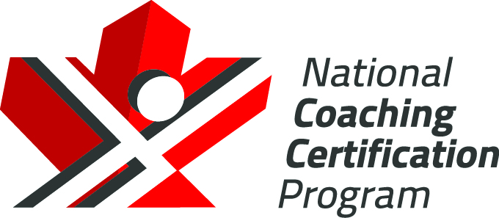

Hockey Canada
High Performance 1
Post Tasks
Version 1.B, 2023

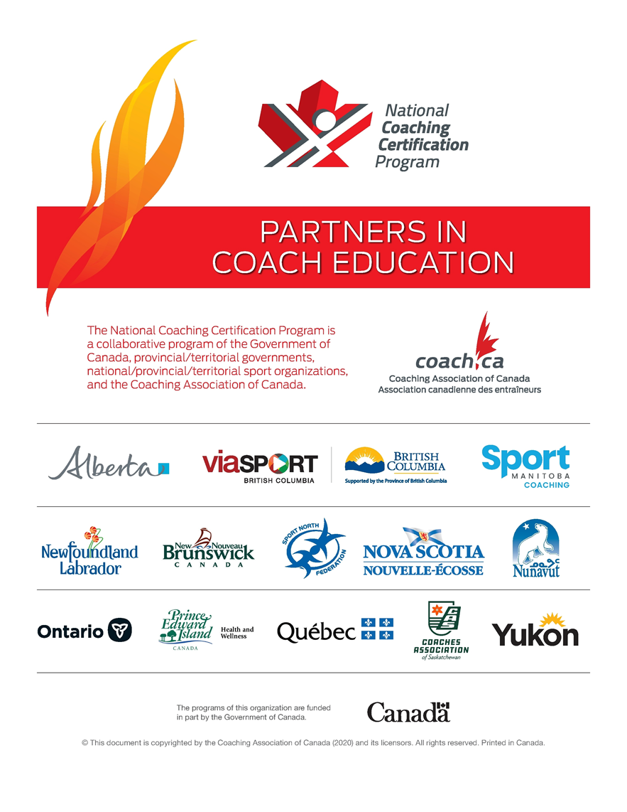
Contents
HP1 Evaluation Part A 1
Seminar Post Tasks 1
Section A: Core Coaching Competencies 2
1. Performance Planning (25 Marks) 2
2. Teaching and Leadership in Coaching (15 Marks) 2
Section B: The Art of Coaching Competencies 3
3. Player Evaluation and Selection (10 Marks) 3
4. Physical Preparation (10 Marks) 3
5. Mental Preparation (10 marks) 3
6. Team Building (10 marks) 4
Section C: Technical, Tactical and Systems Competencies 5
7. Skill Assessment (15 Marks) 5
8. Offensive Team Play (20 marks) 5
9. Defensive Team Play (20 marks) 6
10. Power Play (20 marks) 7
11. Penalty Kill (20 marks) 7
Section D: Modules to be evaluated online 8
1. Leading Drug-free Sport (eLearning and online evaluation) 8
2. Make Ethical Decisions (online evaluation) 8
3. Managing Conflict (online evaluation) 8
Section E: Modules to be Evaluated in the Field Evaluation 9
1. Effective Use of Technology 9
2. Make Hockey Safe 9
3. Game and Bench Management 9

The Collection, Use, and Disclosure of Personal Information
The Coaching Association of Canada collects your NCCP qualifications and personal information and shares it with all NCCP partners according to the privacy policy detailed at www.coach.ca. By participating in the NCCP you are providing consent for your information to be gathered and shared as detailed in the privacy policy. If you have any questions or would like to abstain from participating in the NCCP please contact coach@coach.ca.

HP1 Evaluation Part A
Seminar Post Tasks
Your High Performance 1 post tasks are to be completed by (M/D/YR):
Please submit your Post Tasks to:
Member (BRANCH):
Title:
Phone:
Email:
City: |  |  | Province:
Address: |  |  | Postal Code:

Circumstances may arise, impacting on your ability to complete your post tasks by the date specified above. Extension requests must be submitted to the Member (Branch) or Member Partner in writing.
Group leaders are made available by the Member (Branch) or Member Partner as mentors for your Post Tasks. You may contact your group leader for clarification, direction, confirmation, information and support regarding the components of the HP1 seminar. The e-mail address and phone number of your mentor is identified below.
Group Leader Name:
Phone:
Email:

Section A: Core Coaching Competencies
- Performance Planning (25 Marks)
Planning is the process of assessing a team’s goals and creating a realistic detailed plan of action from meeting these goals. Basic steps in the planning process involve developing a roadmap that outlines the tasks the team must accomplish to meet their objectives.
Utilizing the Yearly Training Plan template (or one of your own), fill in the template with all the activities that you have planned with your team. In terms of yearly planning, please provide the following details for each applicable period and phase of the yearly training plan.
- Goals and objectives for each month
- Player selection / tryouts
- Practices / Games
- Technical / Tactical / Team Play
- Physical performance
- Mental performance
- Team development

Value: / 25

- Teaching and Leadership in Coaching (15 Marks)
Continuing education is vital to a coach’s growth. Throughout the season, coaches will participate in Gold Medal Pathway (GMP) webinars, delivered by Hockey Canada’s Hockey Operations department. Each coach will attend the “Welcome” call plus four (4) webinars. Details will be provided to coaches by your Provincial Member coaching leads.
Part A (10 Marks)
- At the conclusion of each webinar, coaches will document a one-page (1) review detailing three (3) key takeaways/learnings and how they would implement these learnings into a team environment, on or off the ice
A complete answer will be four (4) one-page reviews

Part B (5 marks)
- Outline your plans for building a positive culture amongst your team and developing a leadership team amongst your players

Value: / 15

Section B: The Art of Coaching Competencies

- Player Evaluation and Selection (10 Marks)
In terms of Player Evaluation and Selection please provide the following details.

- Team selection / tryout plan or process
- Evaluation tools that you use to select players
- In season evaluation plan of players - Technical / Tactical / Physical / Mental
- In season tracking tools of player progress - Technical / Tactical / Physical / Mental

Value: / 10

- Physical Preparation (10 Marks)
Provide your in-season physical preparation program. Detail your plans: for pre practice/game warm-up; for post practice/game recovery procedures; for hydration, nutrition and recovery; for improving Critical Fitness Variables (CFV’s); for injury prevention; for managing your support staff or outside resource staff within the Physical Preparation program. As well, as part of your answer, submit the knowledge check from Pillars of Performance.
Question Goal: An in-season physical preparation program.

A complete answer will include:
- Knowledge check from Pillars of Performance video
- Physical preparation outline for the season
- Practice and Game warmups / game cool downs / recovery
- Improving critical fitness variables-CFV- measurement and evaluation of fitness components
- Injury prevention
- Managing support staff
- Any relevant templates should be included.
Value: / 10

- Mental Preparation (10 marks)
Provide the details of your Mental Training Program from the tryout process until the end of the regular season (specific content); timelines; who was responsible to lead / oversee the program; and how you track these).
- Goal Setting
- Emotional Control / Focussing techniques
- Imagery / Visualization
- Self Talk
- Deliberate Practice
- Scheduling – Pre-game / Post-game Messaging

Value: / 10

- Team Building (10 marks)
When asked to define what a team is, most people including coaches, players and even parents readily state that a team is a group of people working together for a common purpose. They will state that things like learning and development of the team and individual members are crucial for success. The most important role and responsibility of the team leader is to build a team.
In terms of ‘team building’ please provide us the following details within a Team Building Plan for the up-coming season.
- Your team values and vision;
- Your keys to successful achievement of your vision and goals;
- A team building ‘Calendar of Events’ showing all team building activities for the season along with the purpose of each activity.
- Community Project-Charity-Fundraiser

These events will also be listed in your Yearly Training Plan Calendar

Value: / 10

Section C: Technical, Tactical and Systems Competencies

These seven modules will be completed via watching a recording on your own time. A link will be provided for you by your Member Branch to watch the recording and complete the post tasks
- Skill Assessment (15 Marks)
There are several reasons why skill development is important. By continually developing a players skills, they will be able to execute plays and strategies more effectively during games.
Part A (5 marks)
- Select a game clip from your team or an NHL / CHL / Women’s game (maximum one minute in length)
- Identify all of the Individual Skills and Individual Tactics (Offensive and/or Defensive) that occur
- Using a practice/drill design template, diagram and describe six (6) individual drills to teach the skills and tactics you identified above (Chain of Events)

Part B (10 marks)
- Complete and submit a player assessment (all players on your team) at the start of the season using the Gold Medal Player assessment template (Contact your Provincial Member for the template)
- Using a practice/drill design template, plan three (3) practices to address/develop the deficiencies you identified in the player assessment

Value: / 15
- Offensive Team Play (20 marks)
Coaches must comprehend that building a complete offensive team play system, involves all of your players so that they can be involved in the breakout, the rush, the entry, and the attack; in all three zones; and that interchanging positions becomes an automatic.
Outline your plans for Offensive Team Play. Reflect on these 4 concepts: 1) Breakouts 2) Neutral Zone Transition/Regroup 3) Zone Entries 4) Offensive Zone Play. Your answer should include:

- Outline of your plan for Offensive Team Play. Include Offensive Principles of Play - Support, Pressure, Puck Control and Transition in relation to the 4 concepts below
- two (2) drills for Breakouts – 1 for a Defensive Zone faceoff win and 1 for a dump in
- two (2) drills for Transition / Regroups – 1 for a NZ Faceoff and 1 for a NZ turnover resulting in an entry
- two (2) drills for Offensive Zone Play – 1 for an Offensive Zone faceoff win and 1 for changing the point of attack
- one (1) drill for Activating your Defence in the rush on a Zone Entry

A complete answer will include:
-your philosophy for offensive team play
-the technical skills required by your players for offensive team play
-the tactical skills required by your players for offensive team play
-seven (7) drills / diagrams and include key teaching points in preparing your answers.
Value: _________/20

- Defensive Team Play (20 marks)
Developing a team that executes outstanding defensive team play systems requires players that are proficient in defensive individual skills and tactics and defensive team tactics. Coaches recognize the importance of practicing these skills and tactics regularly and then integrating them into team play systems.
Outline your plans for defensive team play. Reflect on these 4 concepts: 1) Forechecking 2) Playing the Rush 3) Tracking 4) D Zone Coverage. Your answer should include:

- Outline of your plan for Defensive Team Play - Based on the level you are coaching
- two (2) drills for Forechecking - 1 Skill / 1 Team
- two (2) drills for Playing the Rush - 1 Skill / Team
- two (2) drills for Tracking - 1 Skill / 1 Team
- two (2) drills for D Zone Coverage - 1 Skill / 1 Team
- one (1) drill on angling involving stick on puck in the Neutral zone
- one (1) drill on angling involving stick on puck in the Defensive zone

A complete answer will include:
- your defensive team play philosophy
- the technical skills required by your players for defensive team play
- the tactical concepts required by your players for defensive team play
- ten (10) drills / diagrams and include key teaching points in preparing your answers
Value: _________/20

- Power Play (20 marks)
Your power play can be a weapon or a wimp. Strong offensive teams, in both junior and professional hockey, have power plays that are producing percentages over 20%
Outline plans for your power plays for the upcoming season based on the following: Your answer should include:

- Describe the individual technical and tactical skills of the players you utilize on your power plays.
- Describe the roles and responsibilities (and the names for the positions) of the players on the power play.
- Diagram and explain two (2) drills for a Power Play Breakout
- Diagram and explain two (2) drills for Power Play Entries
- Diagram and explain two (2) power play setups in the off. zone and include responsibilities of each player.
- Diagram and explain two face off strategies, one for a win and one for a loss.
- Describe how you plan to evaluate your power play performance
A complete answer will include:
- eight (8) drills / diagrams including key teaching points in preparing your drills.
Value: _________/20

- Penalty Kill (20 marks)
The power play / penalty kill continues to be a win or lose situation in many hockey games. The team who wins special teams – usually wins.
Outline your plans for your Penalty Kill. Your answer should include:

- Describe the skills and abilities of the players you utilize on your PK and outline your utilization of players.
- Outline two (2) drills for face off strategies and setups in your defensive zone.
- Outline two (2) different 5 on 4 Power Play systems and two (2) 5 on 3 Power Play systems in the Offensive Zone. Now diagram and describe your PK systems against the four (4) different power play systems you outlined.
- Diagram and explain two (2) drills to outline your PK Forecheck.
- Identify how you would use statistical data to support how you evaluate PK performance.

A complete answer will include:

- twelve (12) drills / diagrams including key teaching points in preparing your answers.

Value: _________/20

Section D: Modules to be evaluated online

The following modules require an online evaluation through the Coaching Association of Canada database, the “Locker”. Make Ethical Decisions and Managing Conflict will be delivered virtually by your Member Province or Hockey Canada. Leading Drug-free Sport is on e-learning training and evaluation module to be completed on your own time.
- Leading Drug-free Sport (eLearning and online evaluation)
eLearning / on-demand module that introduces new and experienced coaches to the values of fairness, excellence, inclusion, and fun in the context of drug-free and clean sport practice. Drug-free sport is free of doping, both because participants choose not to dope and because they have the knowledge, tools, and motivation to protect themselves from unintentional doping.
- Make Ethical Decisions (online evaluation)
By successfully completing the NCCP Make Ethical Decisions training and evaluation, coaches will be fully equipped to handle ethical situations with confidence and surety. The training helps coaches identify the legal, ethical, and moral implications of difficult situations that present themselves in the world of team and individual sport.
- Managing Conflict (online evaluation)
Managing Conflict introduces new and experienced coaches to the impact of conflict on sport in their day-to-day coaching practice. This module teaches key skills for achieving positive outcomes using effective conflict management techniques.

Coaching Association of Canada
Website: www.coach.ca
NCCP / LOCKER LOGIN: https://thelocker.coach.ca/account/login?ReturnUrl=%2f

Section E: Modules to be Evaluated in the Field Evaluation
The coach will demonstrate skills, knowledge and attitudes through practices, games and interviews in the FIELD EVALUATION. In addition to all the competencies outlined in Sections A, B, C, D and E, the following competencies will be examined during the FIELD EVALUATION:
.
- Effective Use of Technology
Pre-game interview with Field Evaluator
- Make Hockey Safe
Emergency Action Plan to be submitted to Field Evaluator. Field Evaluator may also interview your teams athletic therapist
- Game and Bench Management
To be observed by your Field Evaluator during game

